Global Perspectives in Marketing Ethics: The Overconsumption of Fast Fashion and Its Impact on the Environment and Society from the Consumers Perspective
Student’s Name
Institutional Affiliation
Date

Introduction
The overproduction in the fast fashion industry has made clothes so affordable leading to the overconsumption, which is unsustainable. The production cycle is repeated in a manner that such that the amount of money is spent on fast fashion, which would have been spent on other sustainable clothing with a longer lifespan (Zhang, Zhang & Zhou, 2021).
Overconsumption Problem and Waste
The overconsumption of fast fashion product has contributed to the release of waste from factories that are toxic including untreated water wastes. These wastes contain untreated water toxic compounds including mercury, lead, and arsenic and when they are released to water sources they become toxic to aquatic and human life.
Significance of the Problem
Overconsumption of fast fashion products are harmful and if not well controlled can have adverse consequences to the environment (Zhang, Zhang & Zhou, 2021).
Aim of the Study
The aim of the study is to assess overconsumption of fast fashion products among consumers and description of strategies based on existing literature and theories to address this problem to establish long term sustainability of these industries.
Consumer Decision Map
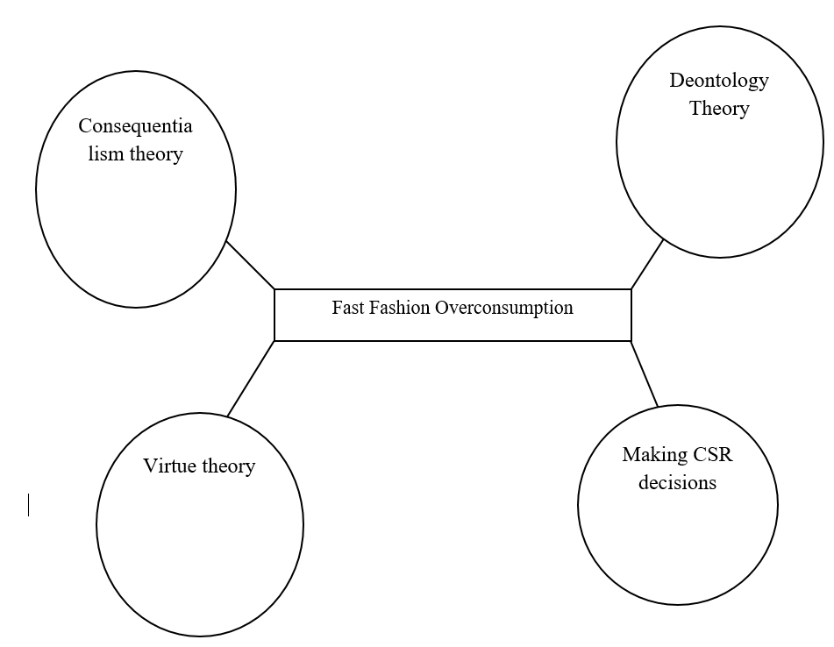
This map will be crucial in addressing the overconsumption of fast fashion because consumers will have to make rational decisions before they decide to purchase certain products. They will have an opportunity to evaluate the benefits against the effects and assess how they will likely impact the environment (Stringer, Mortimer & Payne, 2020).
Things to Address

- Su & Chang (2018) in their research on the factors affecting students’ brand loyalty found that brand awareness, perceived value, and uniqueness are contributing towards fast fashion brand loyalty. Therefore, it is important to help consumers understand both positive and negative impacts of consuming fast fashion products.
- To avoid overconsumption of fast fashion products, consumers should ask themselves about the benefits of the product against the risk such products poses to the environment. Stringer, Mortimer & Payne (2020), demonstrates that if a consumer is aware of the value of their actions through the lens of ethical concerns of their purchasing behavior, they will be focusing on products that have less impact on animal welfare, the environment, and the employee welfare.
- Fast fashion takes a significant toll on the environmental sustainability. Increased demand for inexpensive clothing among consumers has both environmental and social degradation. The increased consumption of the cheap garment has led unsustainable use of water as untreated water is released to water sources (Bick, Halsey & Ekenga, 2018).
- The demand in the fast fashion is not driven by need, but rather wants and brand addiction. However, this is inspired by other factors such as consumer incomes (Mrad et al., 2020).
- According to the theory of mindfulness a consumer becomes aware of the consequences of their decisions and refrains from actions that might have negative implications on the society.
- The opportunities presented will be increased awareness about the fast fashion brand and employing strategy to consume other sustainable brands. Ethics issues associated with such strategy will be unaffordability of high end fashion products from low income bracket.
Conclusion/ Recommendation
The fast fashion industry is impacting the environment negatively. Some of the strategies to reduce overconsumption of such brands are to avoid over purchasing clothes. Customers can also purchase from sustainable brands, which are of better quality, and consider renting or swapping clothes.

References
Bick, R., Halsey, E., & Ekenga, C. C. (2018). The global environmental injustice of fast fashion. Environmental Health, 17(1), 1-4.
Mrad, M., Majdalani, J., Cui, C. C., & El Khansa, Z. (2020). Brand addiction in the contexts of luxury and fast-fashion brands. Journal of Retailing and Consumer Services, 55, 102089.
Su, J., & Chang, A. (2018). Factors affecting college students’ brand loyalty toward fast fashion. International Journal of Retail & Distribution Management.
Stringer, T., Mortimer, G., & Payne, A. R. (2020). Do ethical concerns and personal values influence the purchase intention of fast-fashion clothing? Journal of Fashion Marketing and Management: An International Journal.
Zhang, B., Zhang, Y., & Zhou, P. (2021). Consumer attitude towards sustainability of fast fashion products in the UK. Sustainability, 13(4), 1646.

Hi, please make it clear,
First each section should have couple of pointes with name of the theories and definition and justification
Follow this format for the draft:
- Introduction
- Address the critical issue is being examine? What is important and relevant right now about it, is there changes happening because of this problem, is it getting bigger, why is it important to address ( add theories and relevant studies of the impact of over consumption on the environment and society) the aim of the report! ( reduce the overconsumption of fast-fashion clothing …)
- Body paragraph 1:
  - Address the important of this issue from customers perspectives? Why should we focus on customer perspective rather than business perspectives? Add some theories according to consumers behaviors and ethics and justify why are the threories relevant form what you have read from the literatures
- Body paragraph 2: address the framework (consumer decision- making process ) why is this framework relevant to consumer perspectives of this issue? Address the 5 stages, which possible stages can we use to help fix this problem? Add theories that will be use and why?
- Body paragraph 3: address the challenges of this issue from customers perspectives? Theories and justify?
- Body paragraph 4: address the opportuneness under customers’ perspectives ?
- Recommendations
- Conclusion
- List of references

- Notes : each section should include what will be cover and number of theories and why and write it as pointes.
- Answer the questions with supports of theories, you have to show your understanding of the issue and the theories!
- Kindly search more for relevant literatures regarding this issue and apply some of them, there must be more than 5 references (most importantly the structure and the theories that will be use to solve this ethical issue from customers’ perspectives)

